D3.5

RAMP Marketplace final release

# Document History

|  |  |  |  |
| --- | --- | --- | --- |
| Version | Issue Date | Content & Changes | Author |
| 0.1 | 12.01.2024 | Document created | Panagiotis Bouklis, Themis Kolyvas, Anastasia Garbi |
| 0.2 | 12.01.2024 | Document sent for review |  |
| 0.3 |  | Document reviewed |  |
| 0.4 |  | Document reviewed |  |
| 0.5 |  | Reviews are combined |  |
| 0.6 |  | Sent for Quality Assurance |  |
| 1.0 |  | Quality Assurance and Submission |  |

|  |  |  |
| --- | --- | --- |
| Role | Partner Organization | Name & Surname |
| Reviewer 1 | CSIC |  |
| Reviewer 2 | R2M |  |
| Quality Assurance | SUPSI |  |

# Contents

Document History 2

Contents 3

List of Tables 5

List of Figures 6

List of Abbreviations 7

Executive Summary 8

1. Introduction 9

1.1. Aim and the scope of this task 9

1.2. Relationships with the other tasks 9

1.3. Created value for the end-users 9

2. RAMP in the KITT4SME user journey 11

3. Overview of the service negotiation 12

3.1. Steps of service negotiation 12

3.2. Other features 12

4. Service negotiation step by step 14

4.1. Launching a service negotiation 14

4.2. Needs analysis 16

4.3. Solution refinement 18

4.4. Contracting 19

4.5. Implementation 20

4.6. Completed 21

5. Integration and other APIs 22

6. Overview of other functionalities 23

6.1. Catalogue of Manufacturing SMEs and Service Providers 23

6.2. Data Visualization 24

6.3. Web Workspace 24

6.4. Events 25

7. Evolution of RAMP beyond KITT4SME 26

7.1. Enhancing trust in service negotiations 26

7.2. RAMP future and follow up 26

8. Conclusion 27

9. Control Checklists 28

9.1. The Review Draft Checklist 28

9.2. The QA Draft Checklist 30

# List of Tables

No table of figures entries found.

# List of Figures

Figure 1: Mapping of RAMP features to the KITT4SME user journey 11

Figure 2: Steps of a service negotiation 12

Figure 3: Accessing service requests dashboard 12

Figure 4: Dashboard of service requests 13

Figure 5: Message box embedded in the service request 13

Figure 6: Call-to-Action to use the Adaptive Questionnaire 14

Figure 7: Selecting specific 'Components of Interest' in RAMP 15

Figure 8: Filling additional information for the service request 15

Figure 9: Creating a service request through the dashboard 16

Figure 10: Receiving recommendations and selecting providers to resume negotiation 16

Figure 11: Needs analysis - Manufacturing SME view 17

Figure 12: Needs analysis - Provider view 18

Figure 13: Solution refinement - Manufacturing SME view 19

Figure 14: Contracting - view for both sides 19

Figure 15: Implementation - Manufacturing SME view 20

Figure 16: Implementation - Provider view 20

Figure 17: Completed - Provider view 21

Figure 18: Completed – Manufacturing SME view 21

Figure 19: Catalogue of Manufacturing SMEs and Service Providers 23

Figure 20: Organisation profile page 24

Figure 21: Example data visualisation dashboard 24

Figure 22: RAMP Web Workspace 25

Figure 23: Events page 25

# List of Abbreviations

|  |  |
| --- | --- |
| Acronym | Description |
| API | Application Programming Interface |
| IoT | Internet of Things |
| OCB-LD | Orion Context Broker (with Linked Data extensions) |
| RAMP | Robotics and Automation MarketPlace |
| SME | Small and Medium Enterprise |
| UI | User Inteface |

# Executive Summary

This report describes the final set of functionality delivered by RAMP to enable the interaction of Manufacturing SMEs and Service Providers (mainly developers of solutions for the manufacturing industry). The core functionality is realized by the ‘Service request tool’ which is analysed in the next. The previous activities, under KITT4SME (reported under D3.4), focused on enabling service providers to make their solution available through the Marketplace (RAMP). The work described in this report covers the ‘business aspects’ of the interaction between the End Users and Solution Providers. The term ‘business aspects’ is used to describe the sequence of steps (structured interaction) between the two user categories, so that the End User finds a relevant solution, negotiates its customization with the Solution Provider and procures the customized solution.

This interaction has been fully implemented in RAMP, it is accessible via the link <https://ramp.eu> and has been fully developed for the purposes of KITT4SME from the start.

The last chapter in this report describes also the planned activities for the continuation of RAMP beyond the end of the KITT4SME project (funding secured and strategic commitment of the company supporting RAMP, namely ED).

# Introduction

## Aim and the scope of this task

The Marketplace is the interface between the Manufacturing end-user and the Solution Developer and has a key role especially in their ability to find each other and in their interaction, when it comes to the customization of a solution. The position and role of the Marketplace in the KITT4SME user journey is described in the next chapter. The first release of this report (D3.3) analysed the user needs and developed a prototype implementation of the digital platform that enables the creation of a new kit, that is a bundle of existing solutions. The intermediate platform release (D3.4) focused on the pipeline that enables Solution Developers to upload new solutions as a new offering through the Marketplace. This report (D3.5) describes the pipeline for the interaction/ negotiation between the Manufacturing end-user and the Solution Developer to enable the customization of the solution.

Scalability is addressed in terms of encompassing providers of different type of services so to make easier the creation of bundles of customized services targeting the needs of each individual SMEs. The developed feature in RAMP enables the manufacturing SME to easily discover component bundles that fit their needs and discover also different kinds of service providers from a range of expertise (technologies used) and industry experience.

## Relationships with the other tasks

The RAMP Marketplace is a key component in the pipeline of creating new kits (bundles of solutions) and the interaction between the users. Its relationship with the other platform components is described in the next Chapter of this report “RAMP in the KITT4SME user journey”.

## Created value for the end-users

This release of RAMP, realized under the KITT4SME project, enables the new service called “service negotiation”. RAMP offers additional features for its users, namely: Dashboard of service requests, messaging system, Catalogue of service providers and manufacturing end-users (clients), dashboards for data visualization, an event hub and a web workspace (for the integration of different services through a unified UI).

### Definition of the current problem in SMEs

Manufacturing SMEs usually follow up on the more traditional way of operation, that is they usually try to adapt their production processes to the mechanical tools that enable them to comply with the requested quality standards or production volumes. It is common among smaller manufacturing facilities to miss the skills needed to (a) identify which opportunities from the digital era can create value for them (for example increase quality of production, discover sources of loss from data analytics, etc.), (b) develop and deploy such solutions in their production.

RAMP, in KITT4SME, mainly addresses the first problem. It collects a number of digital solutions for the manufacturing end-users, along with a description of the offering (the problem they intend to solve). It then brings together the people with the appropriate expertise to identify which components fit the corresponding use cases. Through a stage of negotiation tailor-made solutions are formed (specified), so that they can be materialized by the respective Solution Developers and deployed through the KITT4SME platform.

### Measurable description of the status quo

The developers of RAMP (ED) do not know of any digital service that provides this type of consultancy service to Manufacturing SMEs. The process now relies on a direct contact of the manufacturing end-user with specific providers through their own network of connections. It is uncertain whether the service provider chosen/ recommend has the relevant expertise for the specific use case (limited transparency & trust).

### Proposed solution as described in the deliverable

Manufacturing end-users have now the option to submit a new service request, where they describe their problem and receive recommendations from service providers with the appropriate expertise. These recommendations come in the form of suggested digital solutions (in RAMP). The experts come from a pan-european inventory, as opposed to being limited to their own contacts. The negotiation and contracting phases are completed online in a structured way.

### Achieved performance of the solution

The service is complete and allows the submission of a service request, selection of one or more providers to negotiate, files and message exchange, component selection and fine-tuning, online contract repository, confirmation of service provision.

The solution has undergone functional testing by participants (end-users) of the BetterFactory and Shop4CF projects in addition to the project-internal testing.

# RAMP in the KITT4SME user journey

This chapter explains how the described functionality is mapped to the KITT4SME use journey, for the 3 different types of users, the Manufacturing SME, the KITT4SME Platform admin and the AI Developer.

RAMP Marketplace is related to activities of the stages ‘Awareness’, ‘Diagnose’ and ‘Compose’, as indicated in Figure 1.

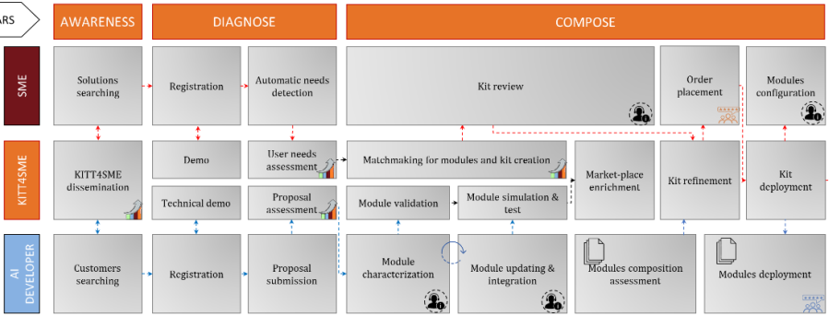

Figure 1: Mapping of RAMP features to the KITT4SME user journey

Figure 1 shows in:

* Red boxes activities which are addressed by the RAMP feature described in this report.
* Red boxes with dashed line activities which are addressed by RAMP features reported in the previous report, D3.4.
* Orange boxes indicate 3d party services (from kitt4sme) that have been integrated with RAMP, more specifically:
  + Automatic needs detection is addressed by the Adaptive Questionnaire.
  + Matchmaking for modules and kit creation is addressed by the Platform Configurator.
  + Module characterization is addressed by the Digital Datasheets.

RAMP has developed additional ways to launch the manufacturing SME journey. In summary, the above journey for the manufacturing SME may be launched in the following ways, elaborated in the following chapter:

* After visiting the KITT4SME website, the Manufacturer can use the Adaptive questionnaire and select to continue on finding a solution for their needs.
* After viewing the available components in RAMP, the Manufacturer expresses interest in one or more components.
* The Manufacturer directly launches a service request in RAMP.

# Overview of the service negotiation

This chapter describes the different steps involved in a service negotiation.

## Steps of service negotiation

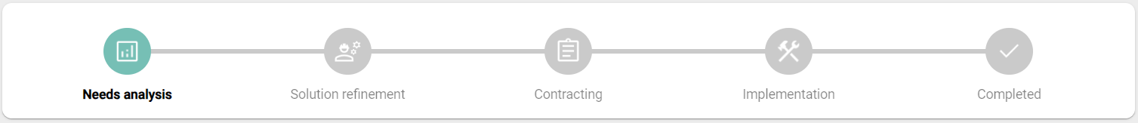

Figure 2: Steps of a service negotiation

A service negotiation is composed of 5 different steps, where the manufacturing SME and the provider interact online and exchange information. The steps are:

1. Needs analysis: In this step, the provider reviews the needs, the use case and the potential preconfigured kit. After the review the provider makes an offer with the final kit and an estimated cost.
2. Solution refinement: In this step, the manufacturing SME and the provider negotiate the main elements of the service, in respect to the components to be used and the estimated cost.
3. Contracting: In this step, the manufacturing SME and the provider negotiate all the details of the service which is stored in a common ‘contract’ online.
4. Implementation: In this step, the provider implements the solution.
5. Completed: This step indicates the fulfilment of the service.

## Other features

### Dashboard of service requests

Any user can review their organisation’s service requests by clicking their profile icon and then ‘Service requests’ (Figure 3).

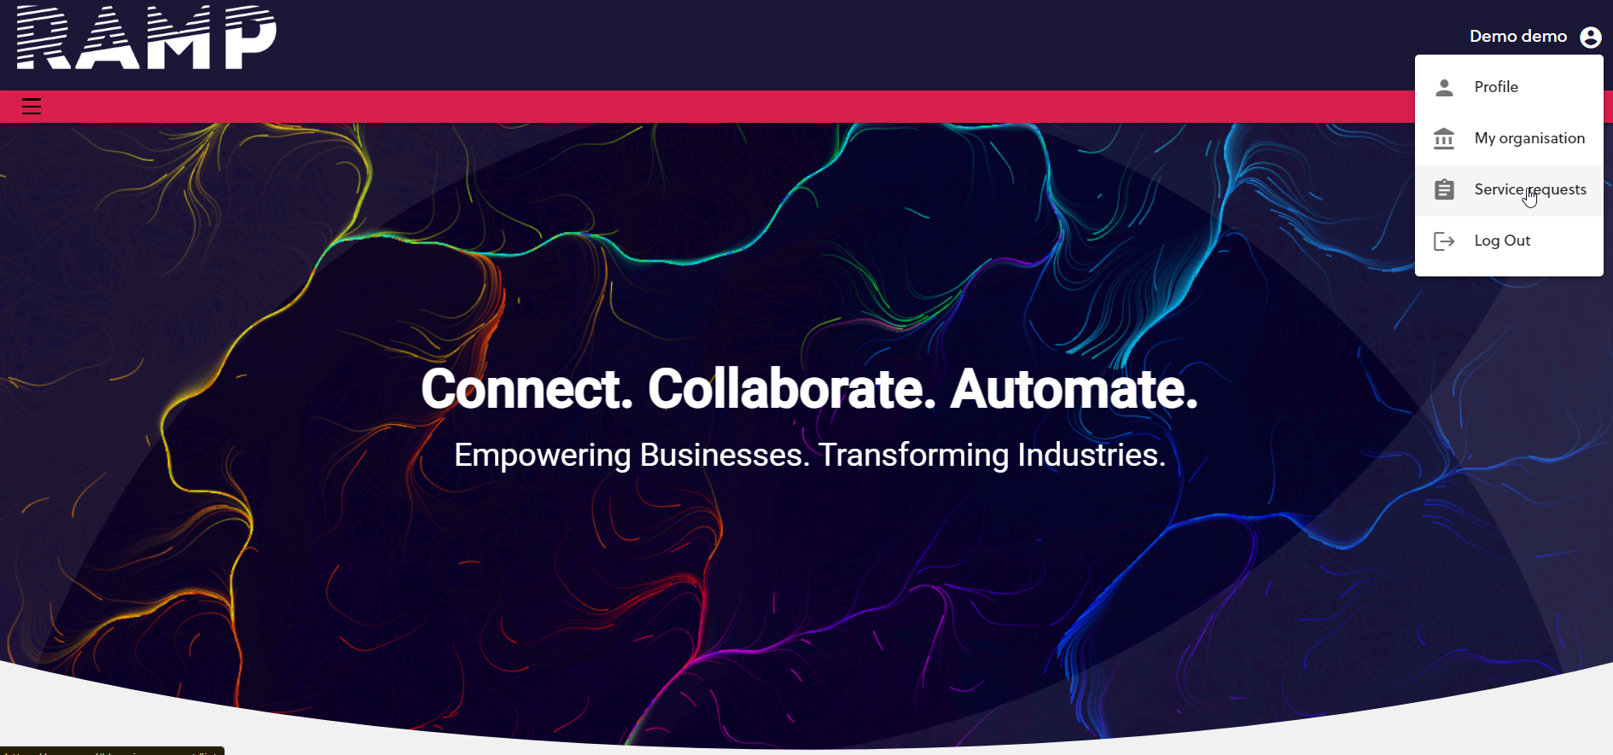

Figure 3: Accessing service requests dashboard

The dashboard shows all the service requests where the user’s organisation is involved. The user can also have a quick overview of the current step in which each service request is, while the user can also change the title of the service request. Completed service requests are also included in the list, dully indicated (Figure 4).

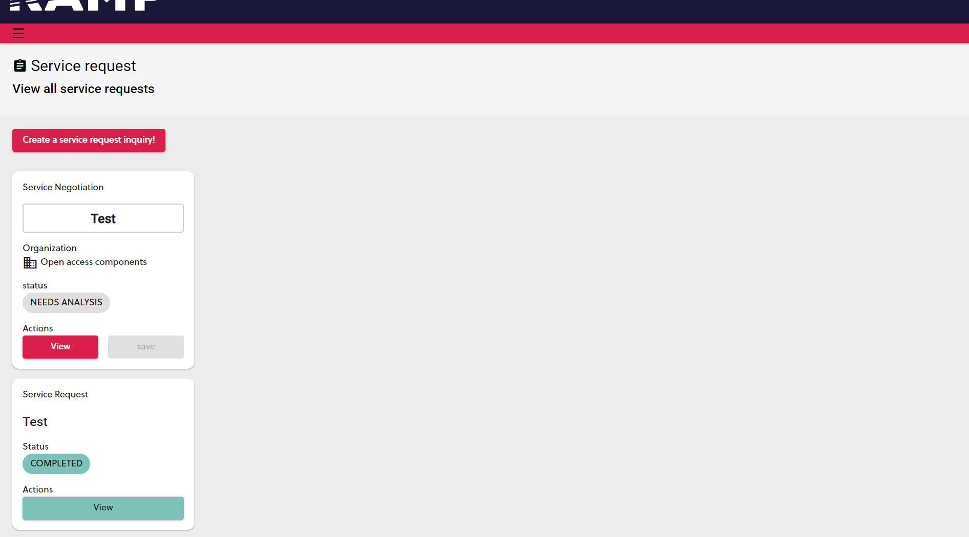

Figure 4: Dashboard of service requests

### Messaging

Each service request has its own message thread. The message box is embedded in the service request screen. All users of both organisations with appropriate access levels participate in the message thread. File exchange is also possible within the message box (Figure 5).

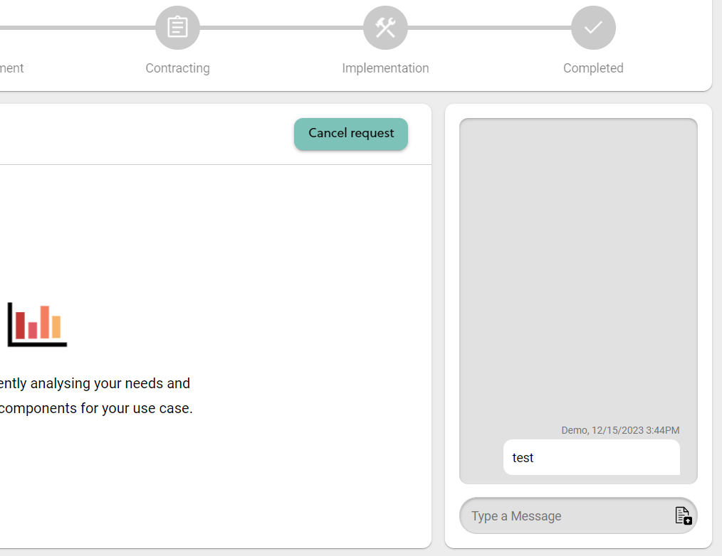

Figure 5: Message box embedded in the service request

# Service negotiation step by step

This chapter describes a service negotiation step by step.

## Launching a service negotiation

As indicated above, the negotiation may be launched from 3 different starting points. According the starting point, the negotiation may or may not have some pre-selected components for the solution to be provided.

### By using the Adaptive Questionnaire

The first way that a service negotiation may be launched is after using the Adaptive Questionnaire.

The manufacturing SME, after reaching the KITT4SME website, for example through a web search or a reference, is invited to use the Adaptive Questionnaire (Figure 6).

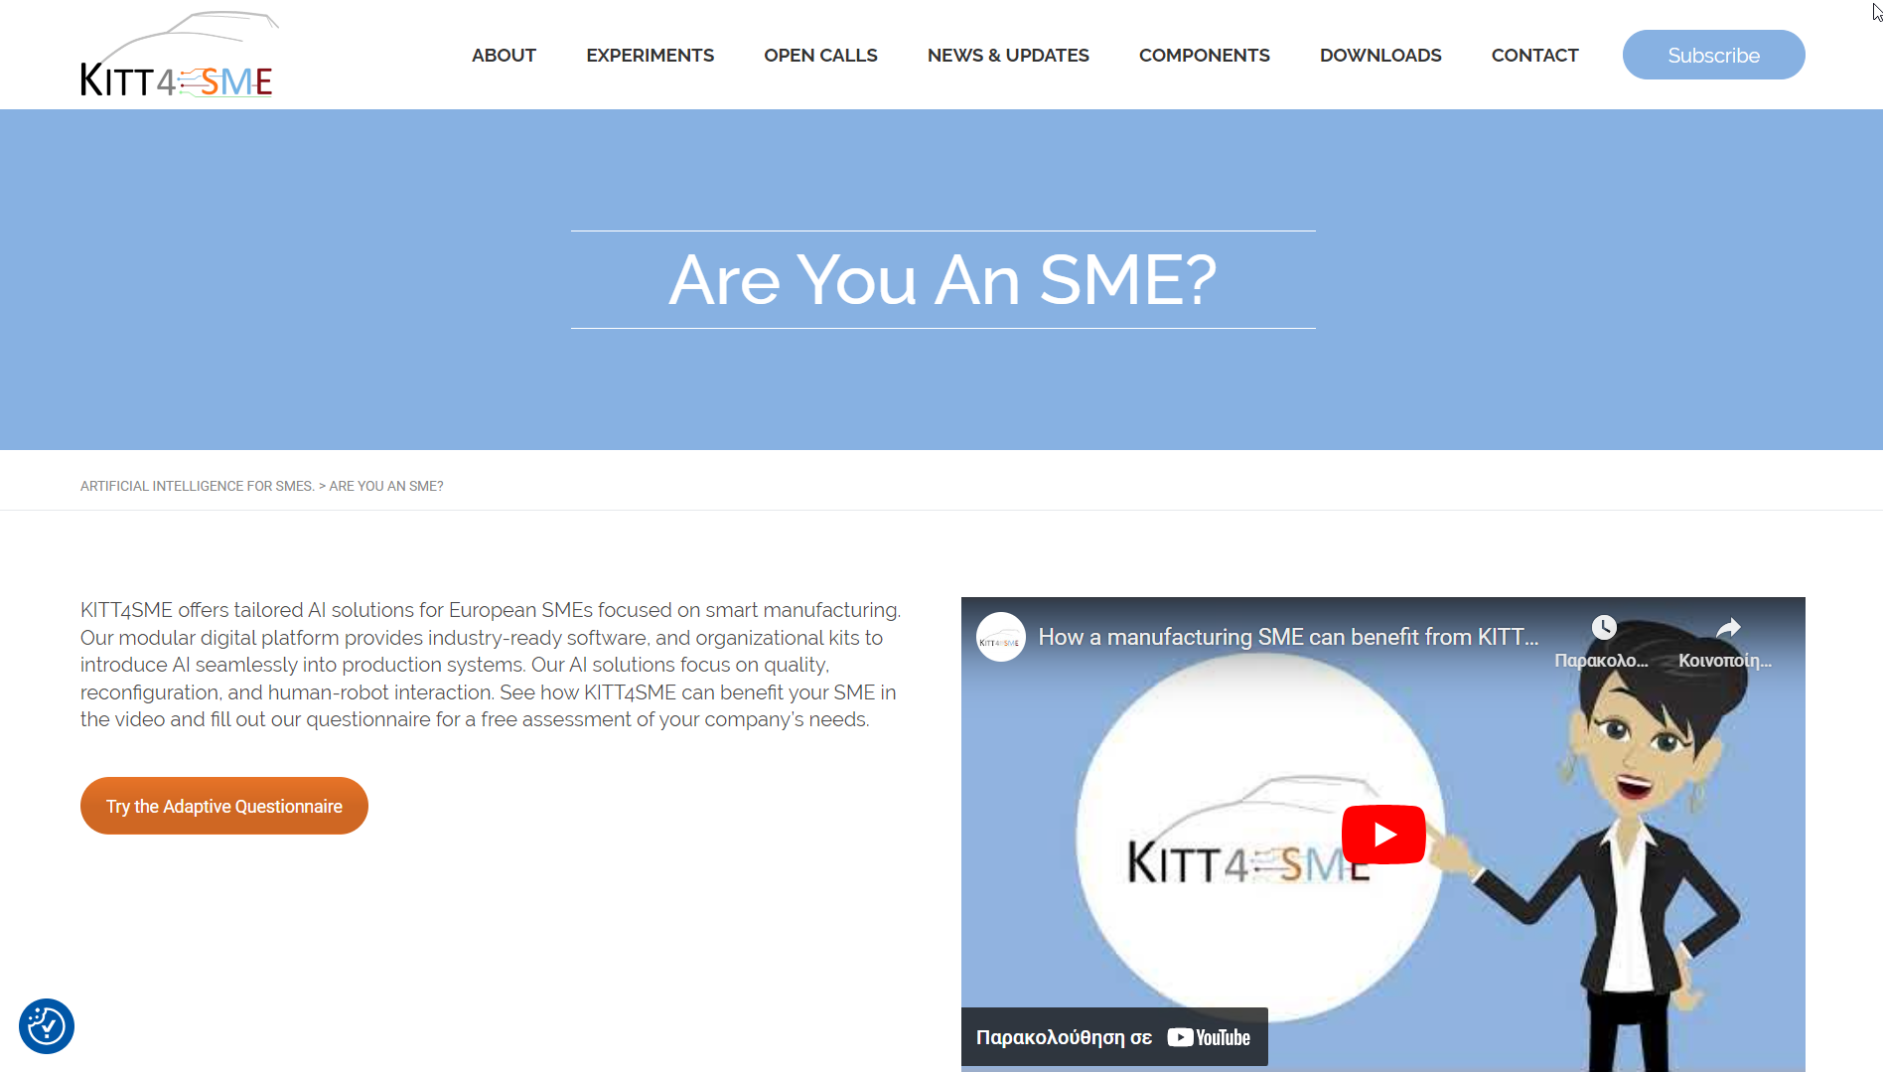

Figure 6: Call-to-Action to use the Adaptive Questionnaire

The user is asked to log in with their RAMP account (or create a new one), the manufacturing SME responds to the series of questions provided by the Adaptive Questionnaire. At the end of the questionnaire, the user is invited to ‘Find a kit for their needs’. If they click the button, the Adaptive Questionnaire forwards the results regarding the needs to the Platform Configurator. Then, the Platform Configurator, according the identified needs recommends the components to be used, from the Digital Datasheets inventory. The needs, along with their values, and the recommended kit (i.e., pre-selected components) are then forwarded to RAMP and a Service Negotiation is launched.

### By expressing interest on specific components

The second way to launch a service negotiation is by directly expressing interest on specific components on the RAMP catalogue. To do so, the user needs to be logged in to RAMP.

By clicking the Component Catalogue (main menu -> Software -> Components), the user can view all the components that are available by developers in RAMP. By simply clicking on the component ‘cards’, the user can edit the list of ‘Components of Interest’ that appears on the left side of the page (Figure 7).

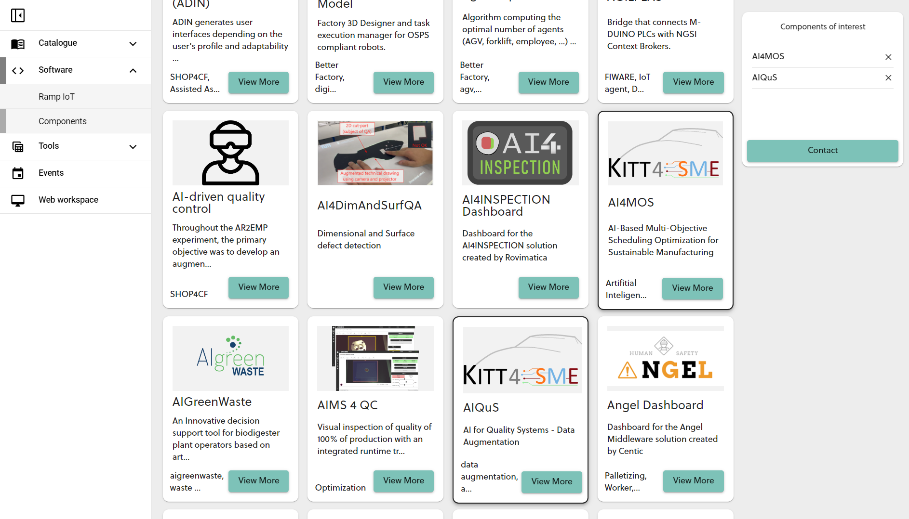

Figure 7: Selecting specific 'Components of Interest' in RAMP

By clicking the ‘Contact’ button, an additional form where the user may fill in a title, a description, and attach any informational files appears (Figure 8).

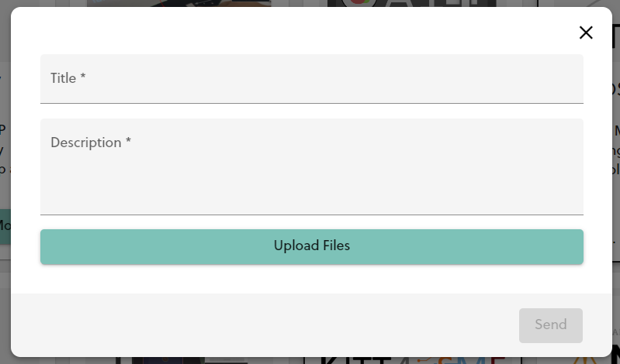

Figure 8: Filling additional information for the service request

Once the user clicks the ‘Send’ button, a new service negotiation is launched, having the ‘Components of Interest’ pre-selected.

### By direct ‘Service request’

The last way to launch a service negotiation refers to a more generic request, where the manufacturing SME simply submits the information of their use case. To do so, the user needs to access the ‘Service Requests’ dashboard and click the button ‘Create a service request inquiry’ (Figure 9). A form similar to the previous alternative appears (Figure 8), where the user can fill in the additional information.

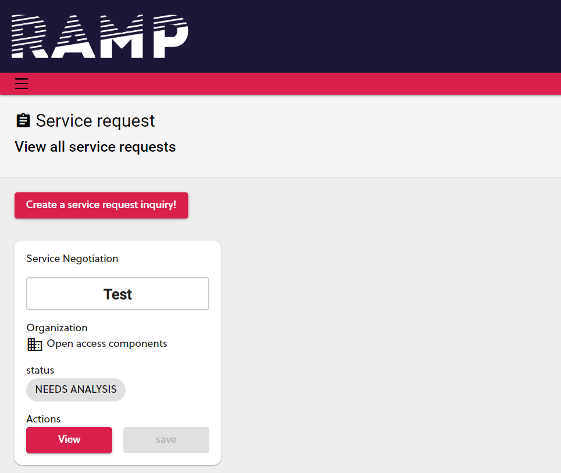

Figure 9: Creating a service request through the dashboard

### Optional selection of service provider

When the service request is launched from the Adaptive Questionnaire, the KITT4SME owner is always the provider. However, in the other 2 use cases there is a preceding process, where the manufacturing SME selects the provider(s) to proceed with the negotiation (Figure 10).

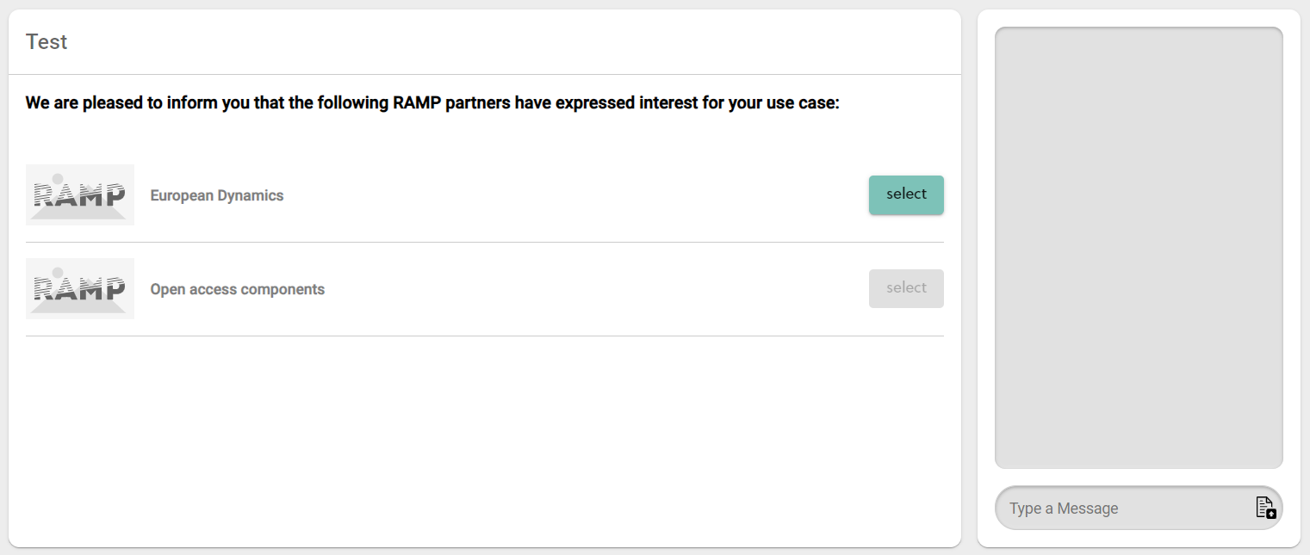

Figure 10: Receiving recommendations and selecting providers to resume negotiation

## Needs analysis

After launching the service request, the relevant information is shown to the provider. The Manufacturing SME can view an informational page to wait for the provider’s feedback (Figure 11). No further action is expected by the Manufacturing SME at this step.

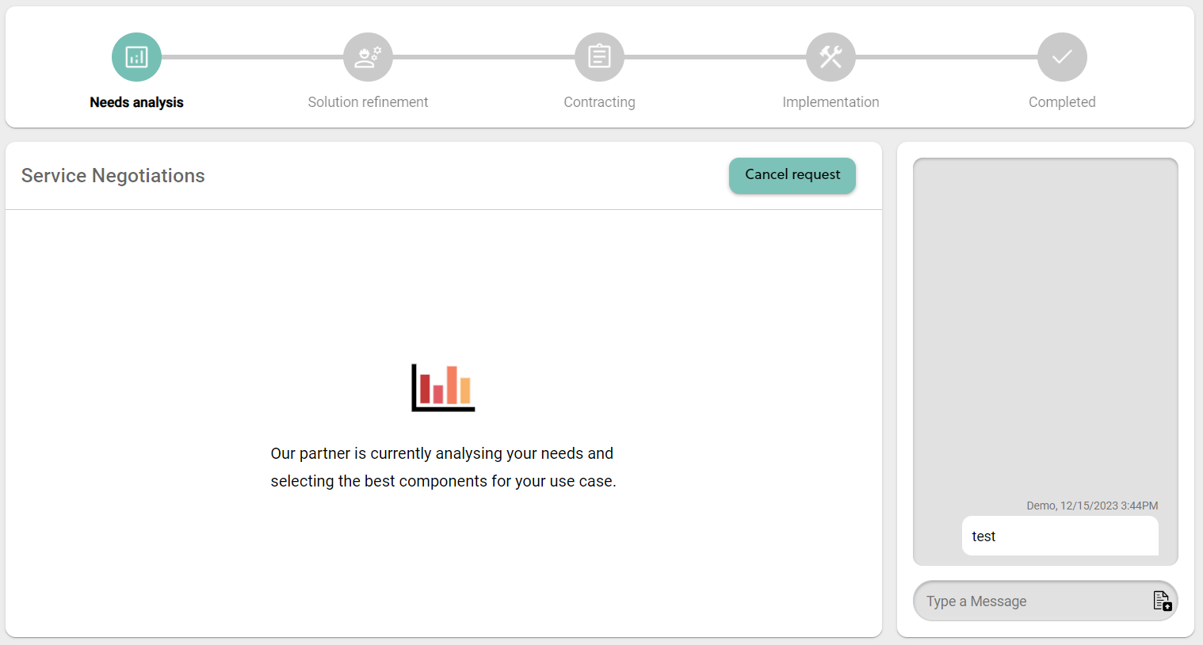

Figure 11: Needs analysis - Manufacturing SME view

On the provider side, the description and the uploaded files are available for review (Figure 12). If the Adaptive Questionnaire has been used, the identified needs are also shown. Below this information, the provider may select different components to recommend as part of the solution. In case there are pre-selected components (i.e., when the service negotiation is launched through the Adaptive Questionnaire, or when the user has selected specific ‘Components of Interest’), these are already in the list of the ‘Recommended Components’, however the list may be further modified by the provider. A field with the ‘Estimated Price’ also needs to be filled in by the provider.

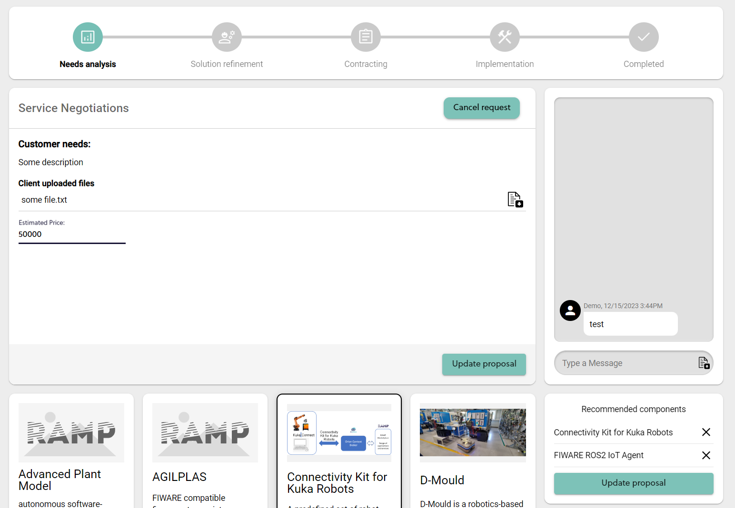

Figure 12: Needs analysis - Provider view

Once the provider clicks the ‘Update proposal’ button, the process transits to the next step.

## Solution refinement

Once the initial offer has been submitted by the provider, the Manufacturing SME can view the recommended components and estimated cost (Figure 13). The Manufacturing SME can view the profile with more information for each of the recommended components by clicking the associated ‘More info’ button. Messaging exchange is expected to be used at this stage to finalise the components that will be used and the estimated price. The view of the provider is the same with the previous steps, and it is possible to modify the ‘Recommended Components’ and ‘Estimated price’. Every time the provider updates their proposal, the relevant information is shown to the Manufacturing SME.

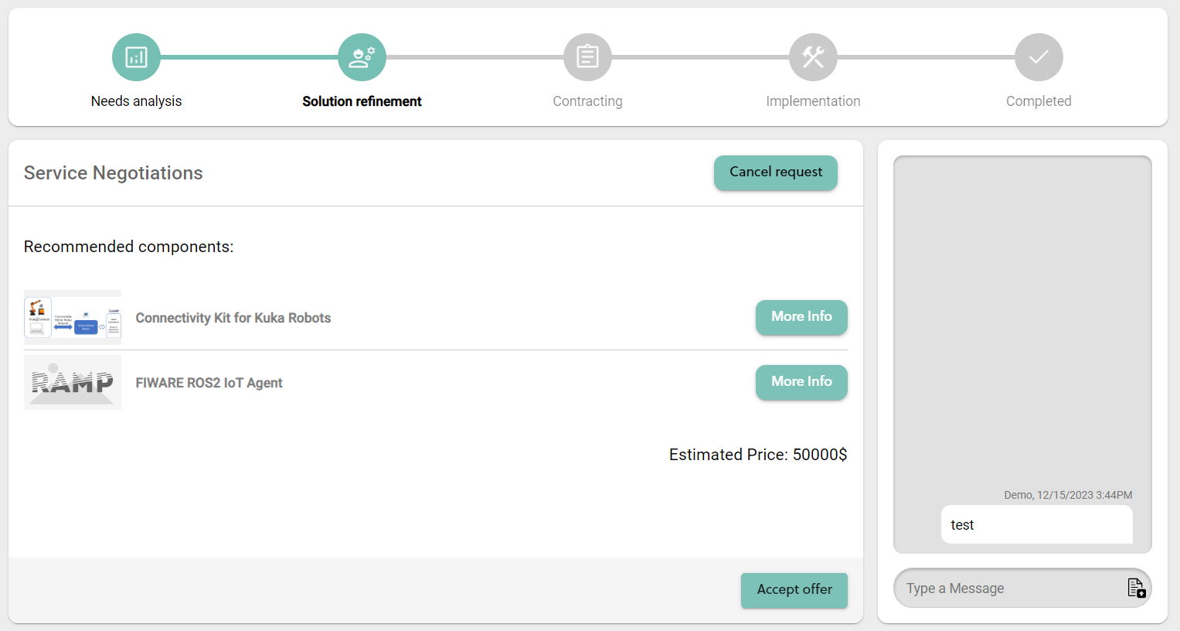

Figure 13: Solution refinement - Manufacturing SME view

Once the Manufacturing SME clicks the ‘Accept offer’ button, the process transits to the next step.

## Contracting

At this step, the two parties negotiate the final service contract (Figure 14). A common file is shared between the two parties and may be uploaded in different versions by both. File history is also available. A template is provided as supporting document (optional).

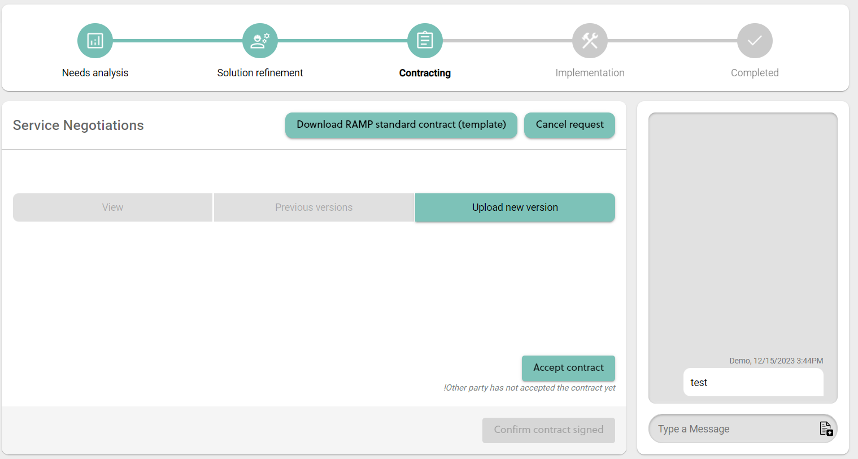

Figure 14: Contracting - view for both sides

Both sides need to ‘Accept contract’ so that the process can proceed to the next step.

## Implementation

The implementation step is expected to take place outside RAMP. The provider is expected for example to implement specific solutions within their factory, on the cloud, etc. Informational pages are shown to both sides (Figure 15, Figure 16).

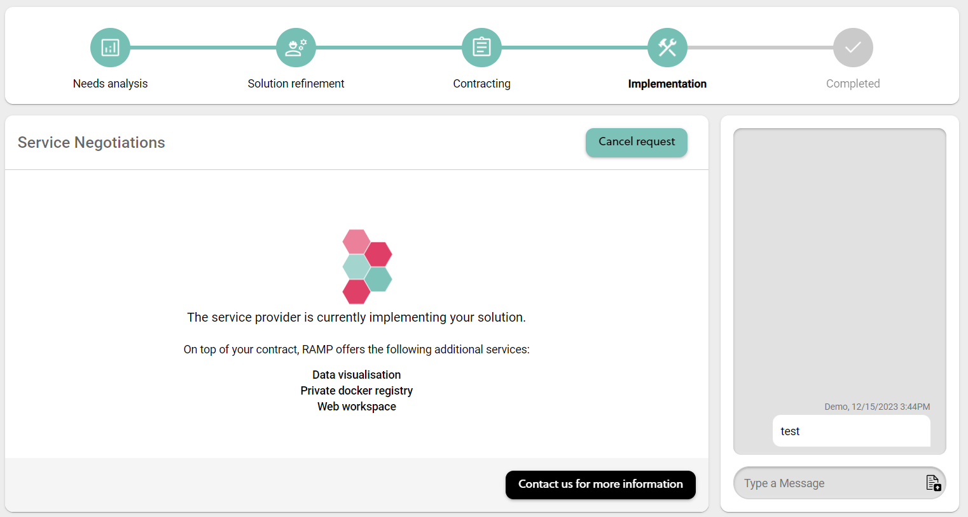

Figure 15: Implementation - Manufacturing SME view

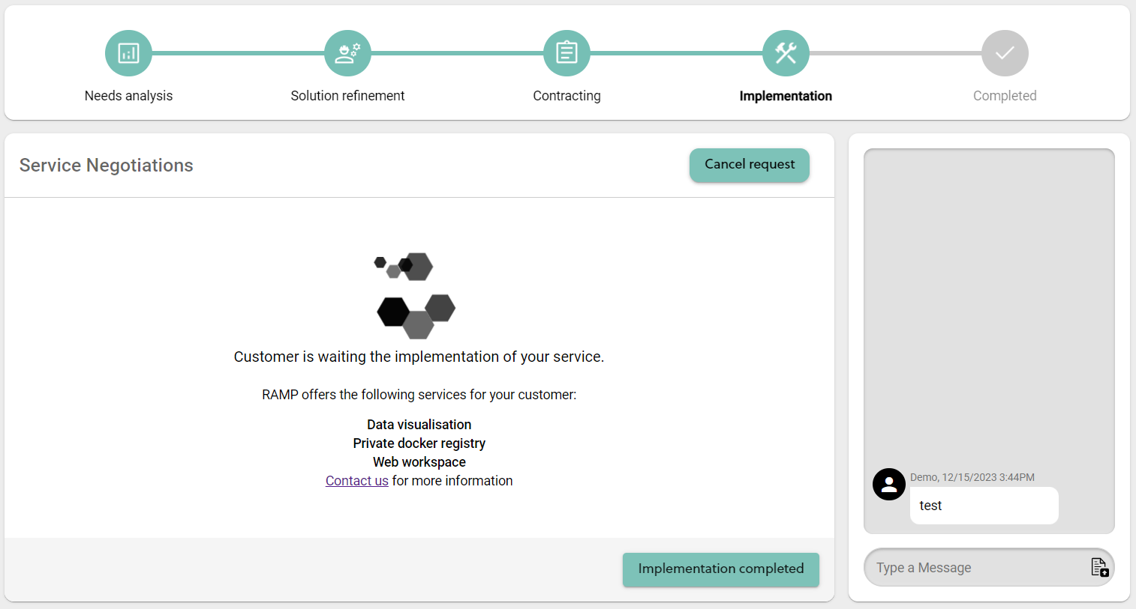

Figure 16: Implementation - Provider view

Once the provider completes the implementation, they need to click the ‘Implementation completed’ button, and the process transits to the final step.

## Completed

At the final step, the transaction is considered as completed. The provider is able to send final information to the Manufacturing SME. (Figure 17, Figure 18) This function remains active, so the provider can update this information many times, as needed.

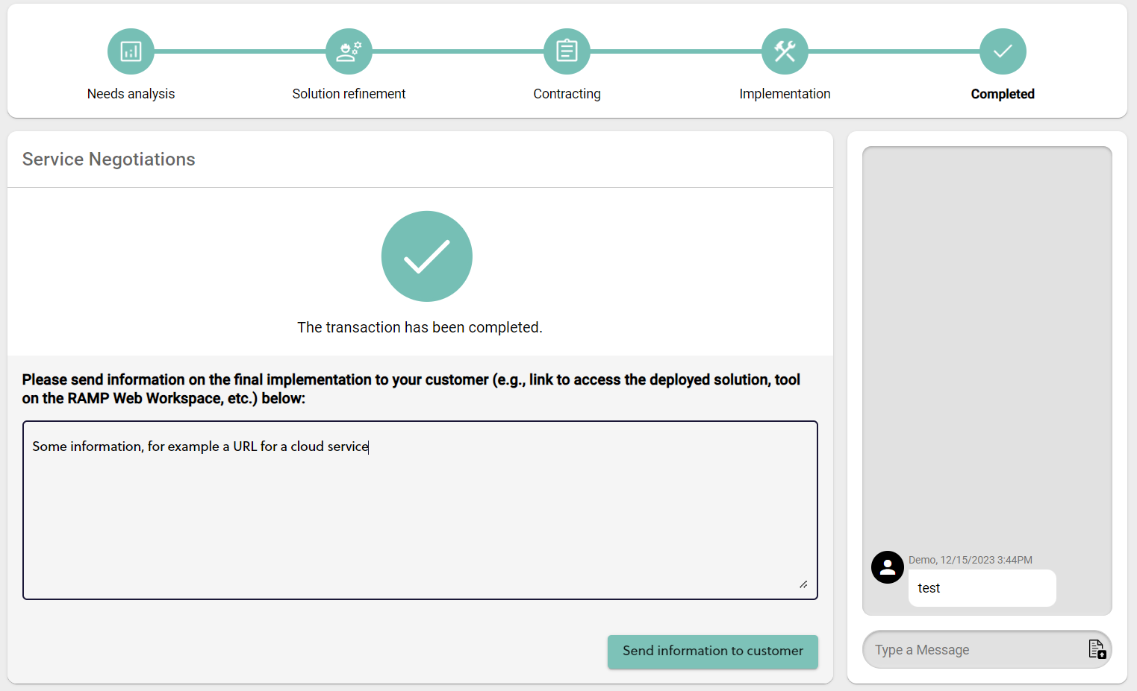

Figure 17: Completed - Provider view

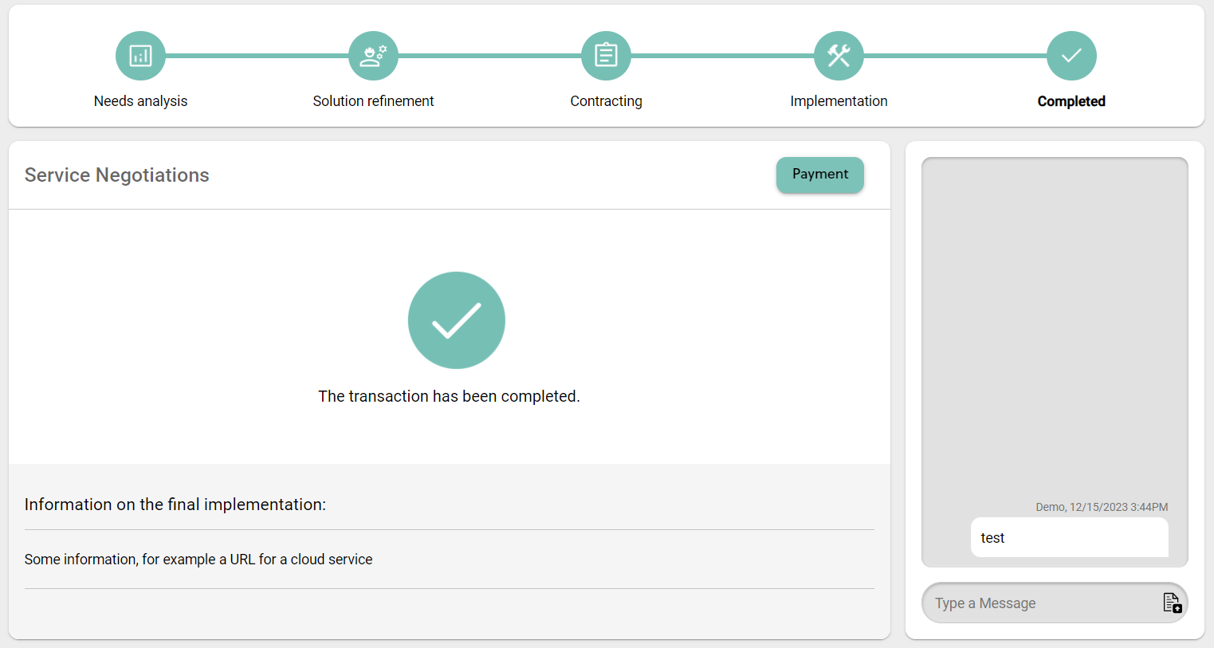

Figure 18: Completed – Manufacturing SME view

# Integration and other APIs

In order to enable a seamless user experience when exploring the KITT4SME solutions, RAMP has developed a number of interfaces to enable the integration with other tools.

More specifically, a Single-Sign-On server that allows the authentication of RAMP users in 3rd-party tools has been configured and customised. The authentication follows the OAuth2.0 standard. The authentication mechanism has been used for user authentication in the Adaptive Questionnaire and in the Digital Datasheets tools.

Another API allows the continuation of the user journey from the Adaptive Questionnaire/Platform Configurator to the service negotiation in RAMP. The API enables the platform configurator to forward the Adaptive Questionnaire’s needs and value list, along with configured kits (composed of a number of pre-selected components).

Another API allows the verification of component ID by the digital datasheets. This is utilised by the digital datasheets to verify that the IDs used internally are aligned with the components listed on the RAMP catalogue.

A third API allows the fetching of aggregated data related to the needs and service negotiation details. This may be used for further analysis.

# Overview of other functionalities

RAMP encompasses a holistic one-stop-solution for digitisation and automation in manufacturing. While this report focuses on the work that has taken place within the KITT4SME project, the RAMP itself includes a range of other features that are aimed to address the needs of manufacturing SMEs and service providers. This is an important element that helps KITT4SME leverage the results of other projects within RAMP, and exploit them for attracting future users to the KITT4SME platform. This chapter aims to briefly present the features that are available in RAMP, and which have not been included in the previous reports.

## Catalogue of Manufacturing SMEs and Service Providers

Any user is able to create their organization in RAMP. The created organizations can also get ‘Verified’ in order to ensure that they are legitimate businesses dully represented in RAMP. The RAMP catalogue includes advanced search and filtering features according to different criteria, while each organization has their own profile, in which they can showcase their expertise and users can contact them.

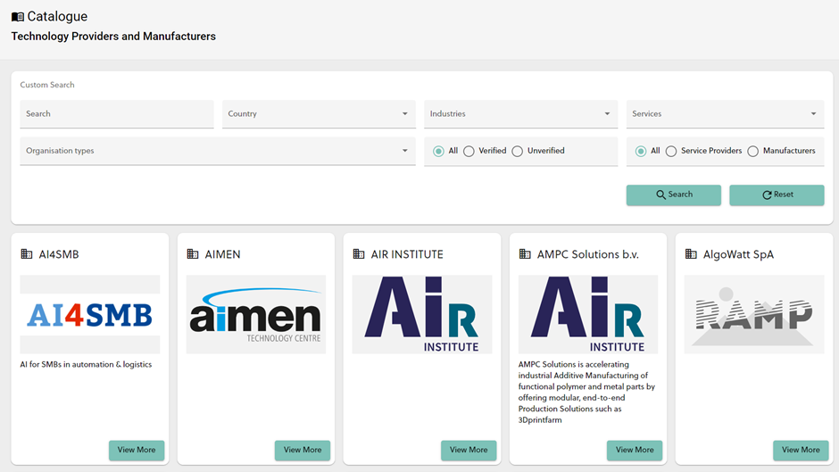

Figure 19: Catalogue of Manufacturing SMEs and Service Providers

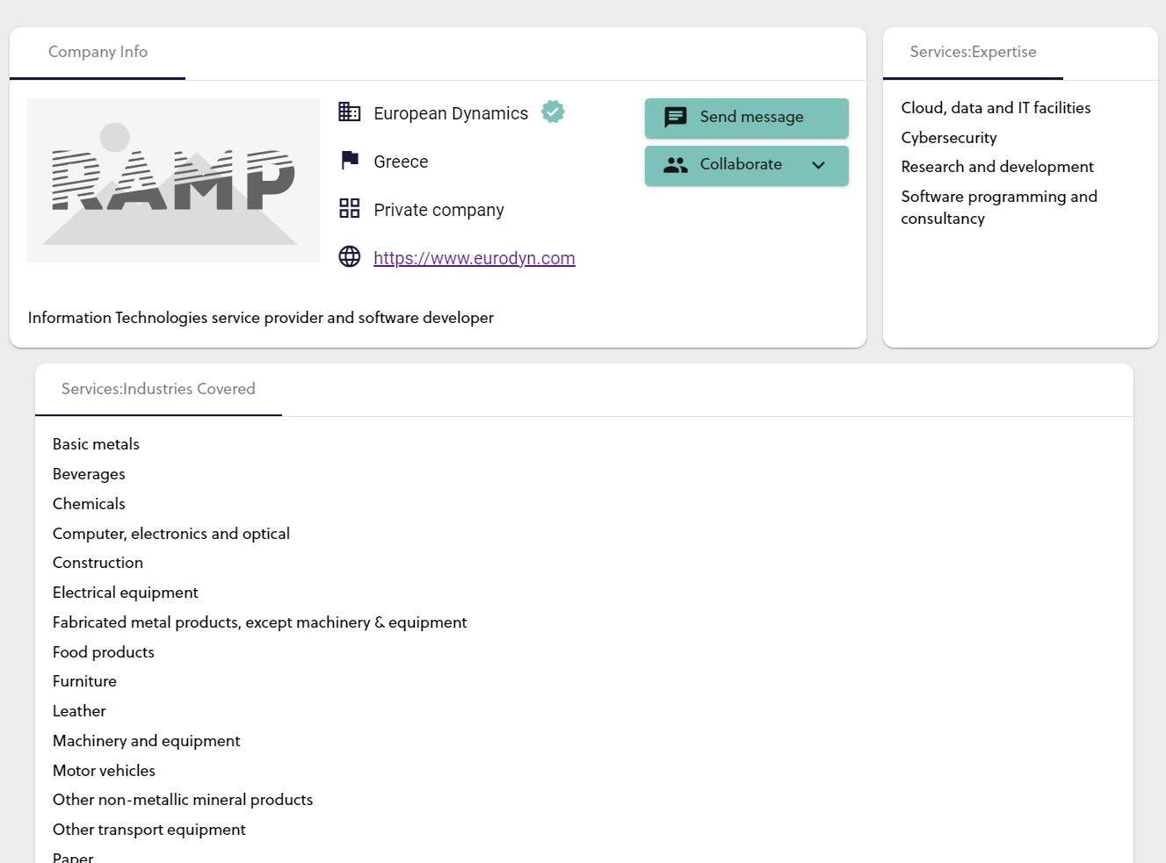

Figure 20: Organisation profile page

## Data Visualization

The data visualization is a Software-as-a-Service tool offered in RAMP. The tool connects to an appropriate database that is made available by the user and allows the visualization of data online. A wide range of different visualisations are possible, while the user can share specific datasets and visualisations with other users in RAMP.

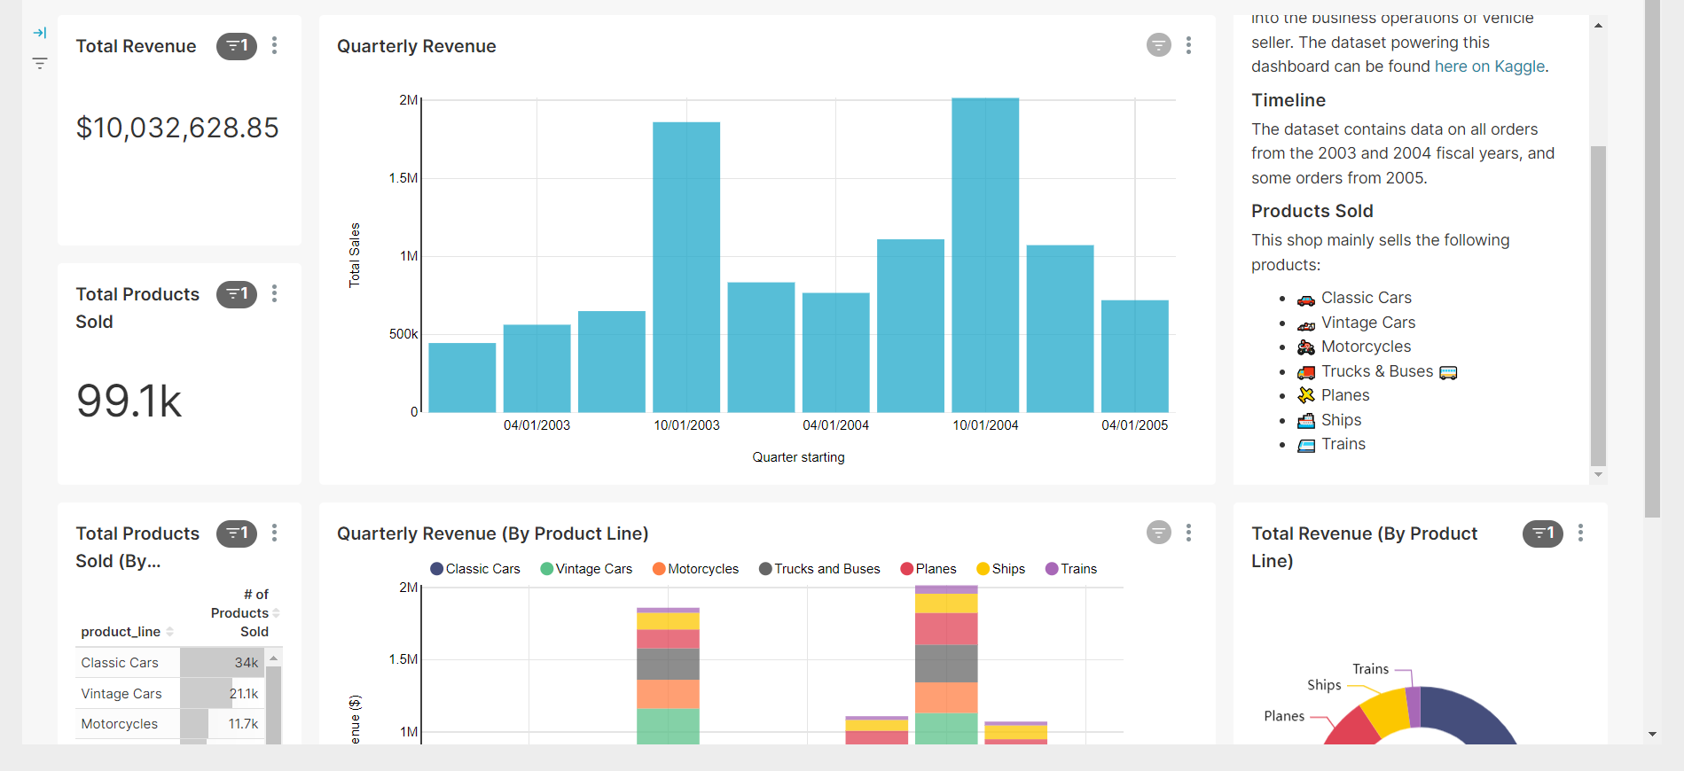

Figure 21: Example data visualisation dashboard

## Web Workspace

The RAMP Web Workspace is a web desktop environment that allows the graphical integration of different web-based app under a common desktop environment. This allows the enhancement of the user experience in using their applications coming from different web-based tool providers under a common environment. RAMP offers also the possibility to have private instances of the web workspace, allowing custom-fit solutions.

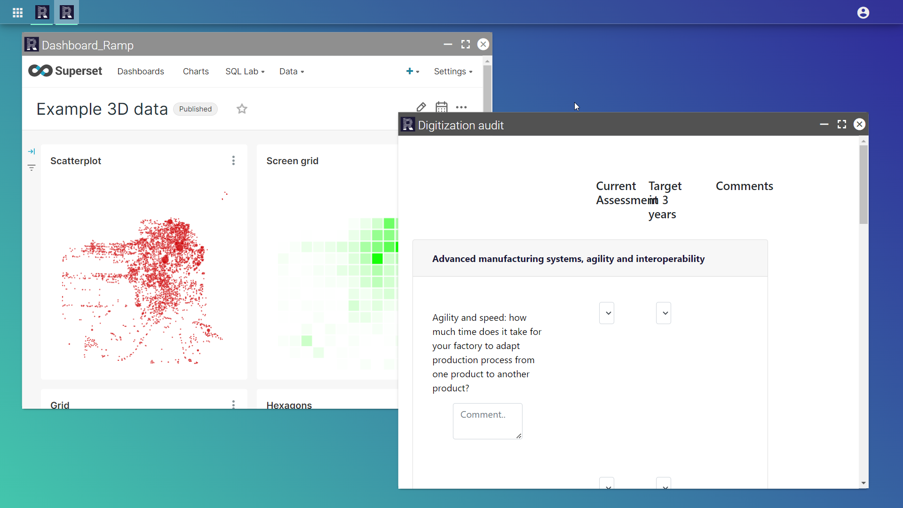

Figure 22: RAMP Web Workspace

## Events

RAMP allows users to submit their events in the events list. Events can be viewed by any user, without registration.

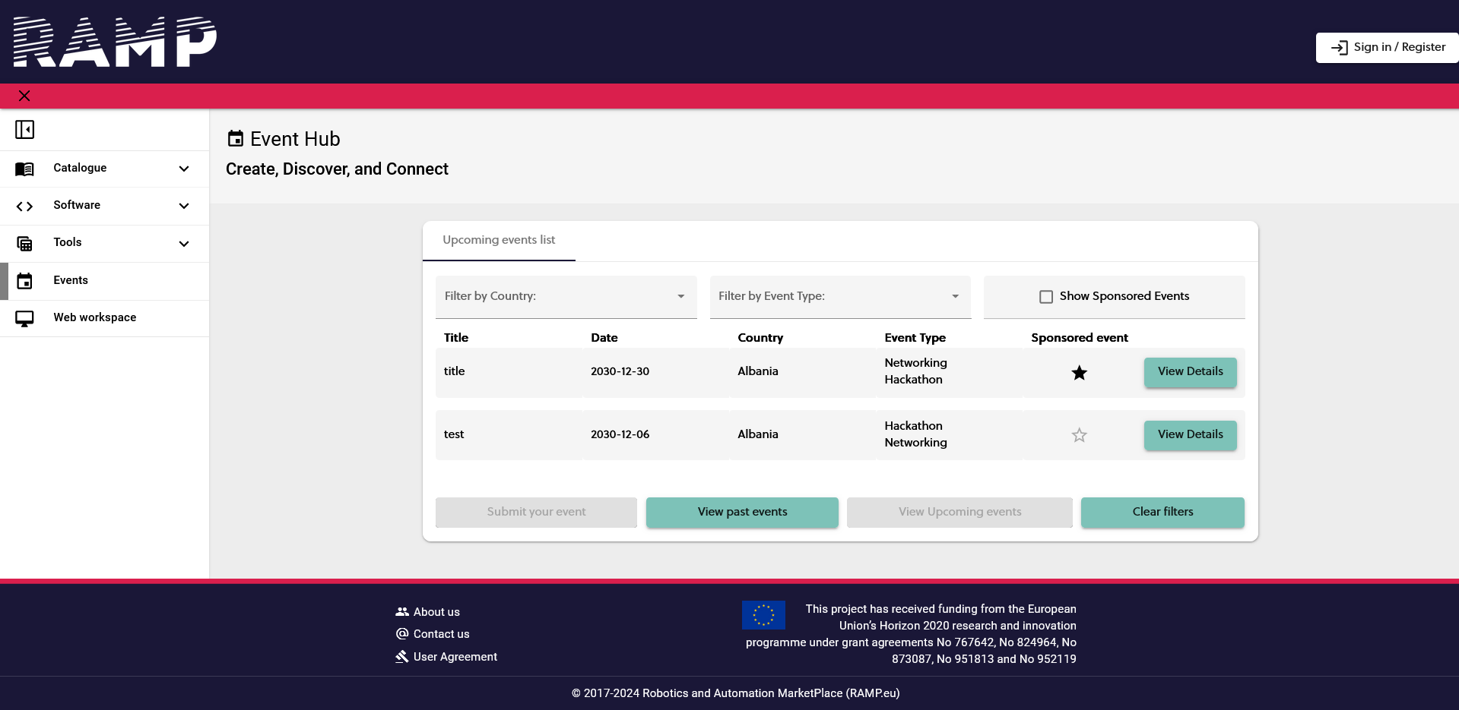

Figure 23: Events page

# Evolution of RAMP beyond KITT4SME

## Enhancing trust in service negotiations

While the negotiation is bilateral, between the Manufacturing SME and the Provider, it is important to enhance trust in using RAMP as a medium for such transactions. For this reason, a Conflict Resolution has been already designed and is being developed (in the context of another project, Better Factory). This tool will be an important asset in promoting the use of the service request tool and make users feel confident in performing such activities in RAMP.

## RAMP future and follow up

RAMP plays an important role in the sustainability of the project’s results, especially the technical ones. The following evidence is provided to highlight the competence of RAMP in sustaining the results after the project:

* Up to 2025: RAMP is also part of the ongoing Better Factory project. Trust-enhancing (e.g., above-mentioned Conflict Resolution) and cybersecurity features are further being implemented and will be soon made available.
* Up to 2026, and beyond: RAMP is part of the DOME project, which will develop a federated catalogue of cloud services – RAMP will be part of the federation. This means that RAMP services and components will be made available in a more wide-focused catalogue, while relevant services from other marketplaces within the federation will be also made available through RAMP. Being a co-investment project (Digital Europe programme), the federation is expected to be sustained after this project’s end.
* Up to 2027: ED, as the RAMP developer, has signed a 4-year contract, starting from the 1st of January 2024, with developers that have been partners in the –now finished- project SHOP4CF. The contract specifies that ED will maintain RAMP and keep the components available in the Component Catalogue, while the developers will continue supporting their listed components (for different timeframes within the 4-year window).
* Up to 2027: RAMP is part of the newly funded CIRCULOOS project. This ensures that RAMP will be further extended with services that facilitate the interactions in circular supply chains for the manufacturing industry (material sourcing from recycling, remanufacturing, decision support on finding most sustainable partnerships (recommender for circular economy)).
* Beyond 2027: RAMP is a strategic product for ED. Via the participation in relevant afore-mentioned projects, the relevant experiments take place in order to identify and test different value propositions and build liaisons, towards building its sustainability beyond the already secured resources.

# Conclusion

This report has defined the problem and the solution offered by RAMP in its final release, namely the ‘service request’ feature. It has described the user-flow and its connection to affiliated platform services, as well as the way it fits to the KITT4SME user journey. Additional features of RAMP are also outlined to provide the context of the features that encompass the experience of users in the Marketplace.

The report provides also an overview of the planned activities (funding secured and strategy) to expand the scope of RAMP and grow its services for its users, with the intention to nurture a community of manufacturing end-users and solution providers.

# Control Checklists

The control checklists are the required section of every deliverable (update Oct. 2021).

There are 2 checklists: *The Review Draft Checklist* and the *QA Checklist.*

* The author(s) must fill up both checklists before sending the document to any review.
* The reviewers must only fill up the Review Draft Checklist before they send the document back to the author for final corrections.

The checklists will be deleted by the coordinator in the Quality Assurance step.

## The Review Draft Checklist

|  |  |  |  |
| --- | --- | --- | --- |
|  | Author | Reviewer | Comments by the reviewers |
| **1. Executive Summary** |  |  |  |
| Are the problems and key questions of interest described? | Yes  No | Yes  No |  |
| Are the main benefits of this deliverable outlined? | Yes  No | Yes  No |  |
| Are the target audience defined? Has the audience been given a reason “why they should read it”? | Yes  No | Yes  No |  |
| Is the executive summary shorter than 1 page? | Yes  No | Yes  No |  |
| **2. Introduction** |  |  |  |
| Is the purpose of the document clearly described? | Yes  No | Yes  No |  |
| Is the technical subject properly introduced? | Yes  No | Yes  No |  |
| Is the information about the document structure, short description of the sections and their relationships are given? | Yes  No | Yes  No |  |
| **3. The main part of the deliverable** |  |  |  |
| Does it contain what was defined in the deliverable description in the DoA? | Yes  No | Yes  No |  |
| If something has been left out, have clear and valid reasons been given as to why? | Yes  No | Yes  No |  |
| Is the title structure consistent? Are the chapters are clearly distinguished from each other and the sections are properly grouped under chapters? | Yes  No | Yes  No |  |
| Are there any chapters having the same name with the deliverable? | Yes  No | Yes  No |  |
| Are there any sections having the same name with the chapters? | Yes  No | Yes  No |  |
| Is the content appropriate for the intended audience? | Yes  No | Yes  No |  |
| Is the terminology clear and consistent throughout the document?  E.g., if there are some “steps” are described in the document, they shouldn’t be phrased as “stages” elsewhere. | Yes  No | Yes  No |  |
| **4. Conclusion** |  |  |  |
| Are any conclusions reached? | Yes  No | Yes  No |  |
| Are any necessary follow-up actions clearly indicated? | Yes  No | Yes  No |  |

## The QA Draft Checklist

|  |  |  |  |
| --- | --- | --- | --- |
|  | Author | QA Resp. | Comments by the QA Resp. |
| 0. Similarity Check  Does the file include a similarity over 50%? Does it include too much information from the generic websites or from the other EC funded projects? | Yes  No | Yes  No |  |
| **1. General** |  |  |  |
| Does the latest deliverable template used?  Download the file to a local drive. *Right click* on the file > go to *Properties > Details*. The info under *Content > Template* should indicate *kitt4sme deliverable template.dotx*. | Yes  No | Yes  No |  |
| Is the deliverable located at the shared folder of the task? | Yes  No | Yes  No |  |
| Is the deliverable document correctly named and versioned? | Yes  No | Yes  No |  |
| Is the name of the deliverable same as it was mentioned in the Grant Agreement? | Yes  No | Yes  No |  |
| Are the text and table styles still usable?  There should be 10 text styles. | Yes  No | Yes  No |  |
| Are the headers and footers correct at every page?  Every page should have the *Dx.z – The name of the deliverable* on the headers and *KITT4SME (952119)* and *Page x/*y in the footers. There should be no headers or footers in the back cover page. | Yes  No | Yes  No |  |
| Are the page margins correct?  Top margin is: 2,5 cm and others are 2 cm each. | Yes  No | Yes  No |  |
| **2. Document information page** |  |  |  |
| Is the dissemination level (confidential / public) selected correctly? | Yes  No | Yes  No |  |
| Are the abbreviations given in the alphabetical order? | Yes  No | Yes  No |  |
| Are the Author’s name, dates and the version name correct? | Yes  No | Yes  No |  |
| Are the reviewers’ names written correctly?  The accented letters in the names must be duly respected. | Yes  No | Yes  No |  |
| Does all the versions of the document available on the shared folder? | Yes  No | Yes  No |  |
| **3. Text formats** |  |  |  |
| Does all the text formats match with the pre-defined text styles (normal text & headings)? | Yes  No | Yes  No |  |
| Are there any extra “enter”s placed between paragraphs to create spacings? | Yes  No | Yes  No |  |
| Are all the bulleted lists in proper alignment? | Yes  No | Yes  No |  |
| Are all the numbered normal texts in proper alignment?  The normal text must only be numbered using the “Numbered Text Styles” (refer to **Error! Reference source not found.**) | Yes  No | Yes  No |  |
| Does every sentence in the document ends with a period (.)? | Yes  No | Yes  No |  |
| Does every bulleted list or numbered list contain a proper semicolon (;) or a comma (,) at the end of every line and contains a period (.) at the last line? | Yes  No | Yes  No |  |
| **4. Table formats** |  |  |  |
| Are the table styles respected? | Yes  No | Yes  No |  |
| Does the table styles autofitted to window? | Yes  No | Yes  No |  |
| Do the table captions fit the defined rules?  The “**Label**” of the caption must be bold, and the rest must be non-bold. All captions must be below the table. | Yes  No | Yes  No |  |
| **5. Images** |  |  |  |
| Are the texts inside the images readable? | Yes  No | Yes  No |  |
| Are the image captions given correctly?  The “**Label**” must be bold, and the rest of the “caption” must be non-bold. All captions must be below the image. | Yes  No | Yes  No |  |
| Are there any non-cited or possible copyright protected images in the document? Are the sources of images clearly given? | Yes  No | Yes  No |  |
| **6. References** |  |  |  |
| Is there a references section? | Yes  No | Yes  No |  |
| If yes, are there citations exactly placed where the references have been used?  Note that documents that cannot be publicly accessible and/or unreliable sources should not be used as references. | Yes  No | Yes  No |  |
| Have the cross-references given correctly? Any “error”s found?  Update all the fields in the document by Ctrl+A > *right click > update all*. Search the whole document for the term “error” | Yes  No | Yes  No |  |
| **7. Confidentiality** |  |  |  |
| Does the document contain confidential information (e.g., names, contact details, confidential company information, etc.) | Yes  No | Yes  No |  |

